TC API – Rounds For Problem API
Deployment Guide

Revision History
Author | Revision Number | Date
panoptimum | 1.0 | 2014/12/12
Deployment Instructions 3
1.Organization of Submission 3
2.Application Setup 3
3.Build Scripts Setup 3
4.Database Setup 3
5.Deployment Instructions 5
6.Starting 5
7.Verification 5
Resource Contact List 12

Deployment Instructions

Organization of Submission
This submission is based on:
- https://github.com/cloudspokes/tc-api.git#bd4226a0202153d0a5b1e565eb485d94b1dfd5d6
- https://coder.topcoder.com/internal/database/scripts/trunk Rev: 85435
The submissionfolder contains the following subfolders:
- submission/tc-api contains changes made to the tc-api
- submission/db contains the following scripts:
  - topcoder_dw__insert.sql to insert test data into db
  - topcoder_dw__clean.sql to clean test data from db
- log contains test and server logs
  - mocha.log the output of ./node_modules/.bin/mocha -R tap test/test.userAlgoChallenges.js
  - jslint.log – jslint output
- The current revision of informix-wrapper is broken, the included package.json refers to the previous working version.

Application Setup
Unzip the submission folder into a folder of your choice, e.g. foo
Now there should be the following structure
foo /submission
Issue the following commands:

git clone https://github.com/cloudspokes/tc-api.git
cd tc-api
git checkout dev
git checkout -b rounds_for_problem bd4226a
cd ../submission
tar -cvf – tc-api | tar -C .. -xf -
cd ../tc-api
npm install java && npm install
source deploy/development.sh

For more specific setup instructions for tc-api, please take a look at the wiki:
https://github.com/cloudspokes/tc-api/wiki

Now the folder structure should be the following:
foo/submission
foo/tc-api

Build Scripts Setup
There should be no special setup needed. If there is a problem, please follow the instructions
in https://github.com/cloudspokes/tc-api/wiki

Database Setup
Now I assume you have a VM running the database at your hands:
ssh tc@tc.cloud.topcoder.com
cp .ssh/authorized_keys /tmp
su informix password: 1nf0rm1x
cd
cp /tmp/authorized_keys .ssh
exit
exit

scp submission/db/*.sql informix@tc.cloud.topcoder.com
ssh informix@tc.cloud.topcoder.com
dbaccess – topcoder_dw__insert.sql (to insert test data)
dbaccess - topcoder_dw__clean.sql (to remove test data)

Deployment Instructions
cd foo/tc-api
source deploy/development.sh
npm start

Starting
See 5.

Verification
Open another terminal, issue the following commands:
cd foo/tc-api
source deploy/development.sh
./node_modules/.bin/mocha -R tap test/test.srmRoundsForProblem.js
You should get output like the following, showing everything works smoothly:

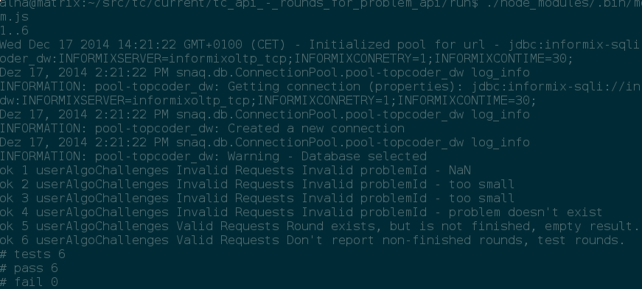
For jslint verification, first install jslint using
$ npm install -g jslint

Running jslint with
$ cd submission
$ find ./tc-api -iregex '.*\.js$' -type f -print0|xargs -0 jslint
you should get the following output:
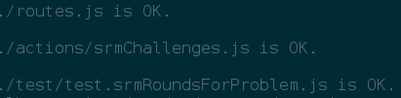

For manual testing you can deploy postman like

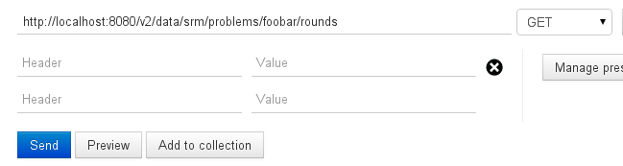Invalid problemId - Not a Number - Postman Form

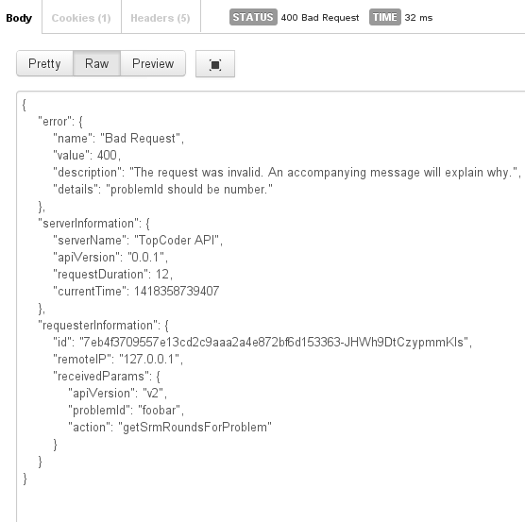Invalid problemId - Not a Number - postman result.

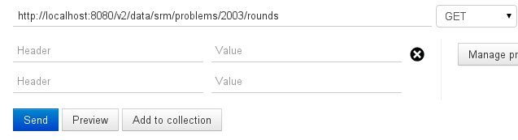Invalid problemId - Not Found - Postman Form
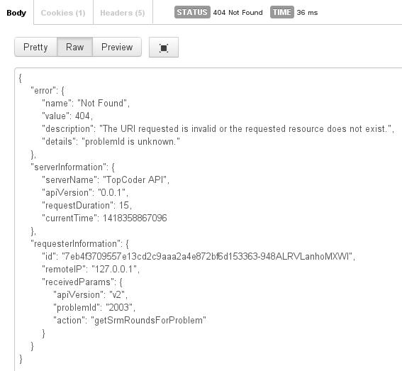Invalid problemId - not found - postman result

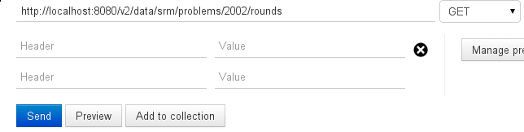Valid Request - No Rounds available - Postman form

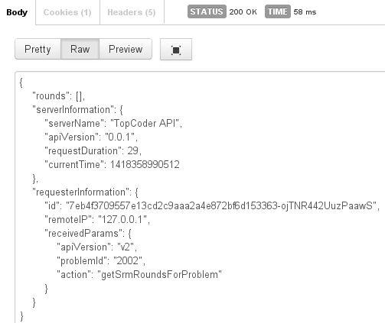Valid API Request - No Round available - postman form

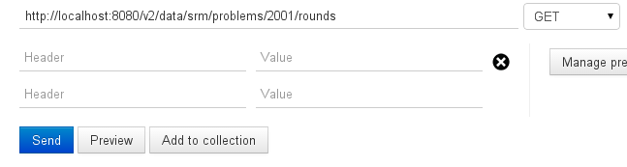Valid Request - Show results - postman form.

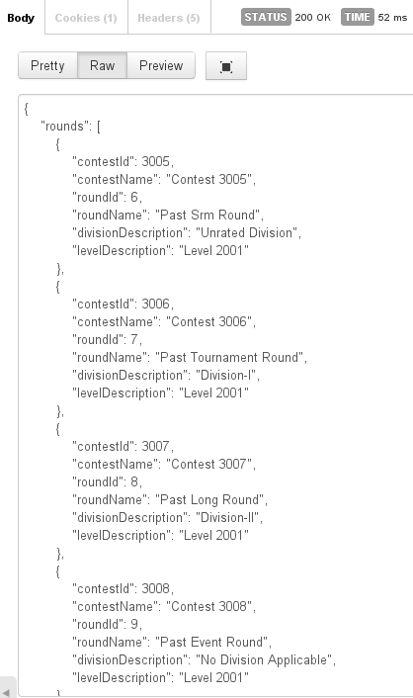Valid Request - Show Results - postman results

For apiary validation sign in to https://app.apiary.io , create a new api or reuse an old one,
paste the apiary into the editor and click the
preview button. You should see something like the following, which confirms the documentation
is valid:
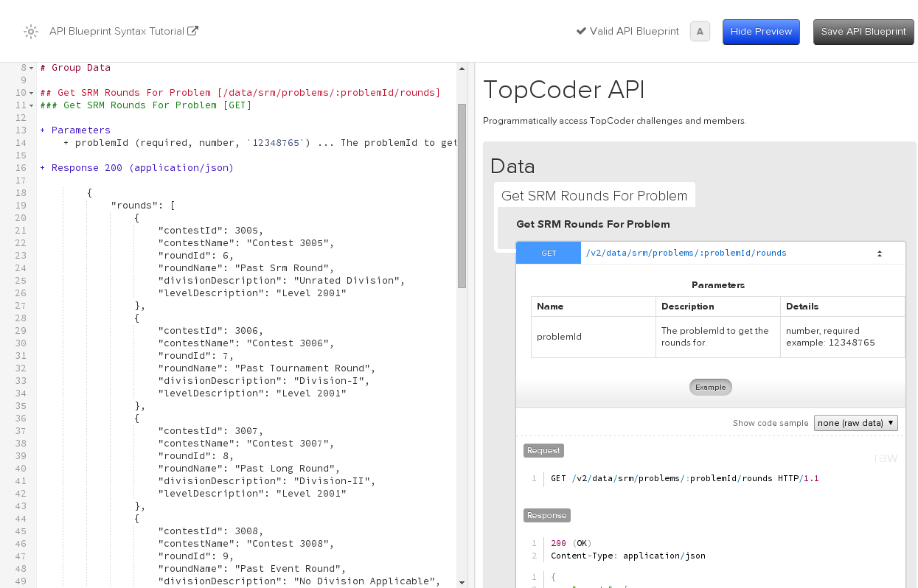

Resource Contact List

Name | Resource Email

